**Screenshot of Solutions and Testing**

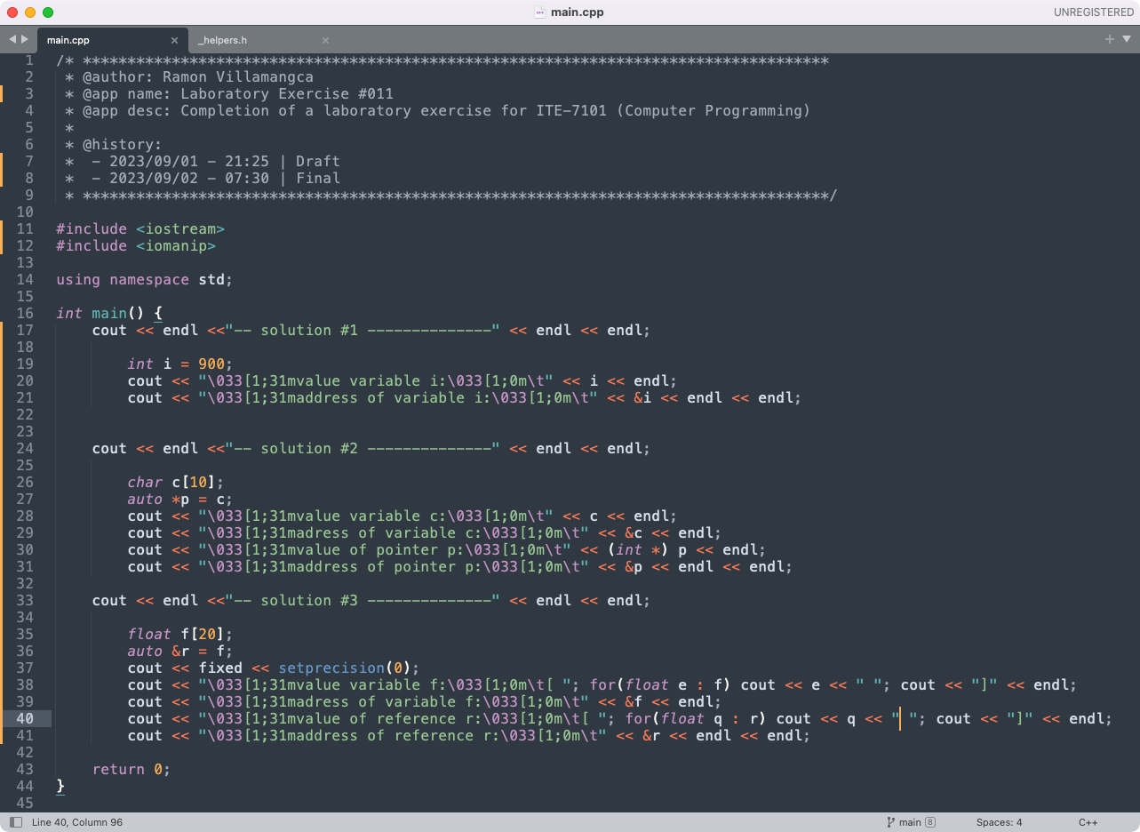

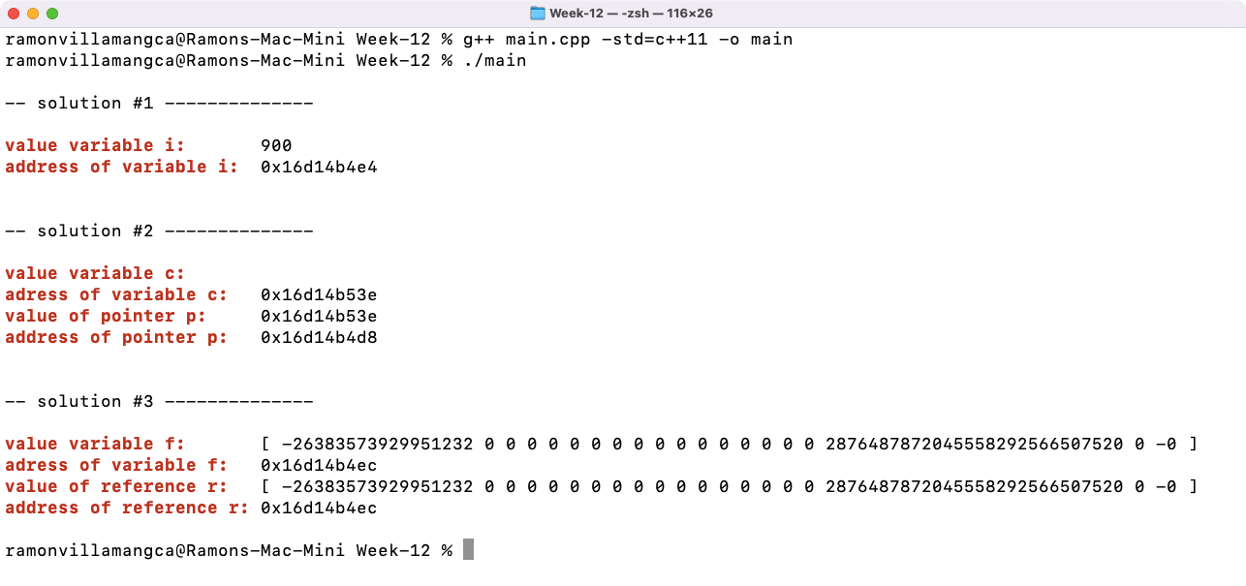

-----------------------

**Problem 01**

Write a program that will display the value and logical address of an integer variable with an initial value of 900.

**Solution 01**

The solution is straightforward. To get the address of the variable we just use the “address of” operator “&”.

The screenshot of the solution program as well as testing in the terminal, is shown above.

-----------------------

**Problem 02**

Write a program that will display the value and logical address of an uninitialized character array with size ten (10) and a pointer pointing to the array. (Hint: you may need to perform some casting.)

**Solution 02**

By default , C++ fills an uninitialized character array by the terminating character ‘\0’. And since “cout” reads a character array as a string, we expect that “cout” will print “blank string” for the character array variable.

Since the array variable name is also designated as its address. To get a pointer to the array we just assign the name of the array to the pointer. However, since “cout” interprets “char[]” and “char*” as both string, if we want to print the value inside the pointer we need to cast the pointer to an integer pointer “(int*)” or to any non-character pointer type.

We expect the address of the array would be equal to the value inside the pointer.

The screenshot of the solution program as well as testing in the terminal, is shown above.

-----------------------

**Problem 03**

Write a program that will display the value and logical address of an uninitialized float array with size twenty (20) and a reference pointing to the array.

**Solution 03**

As in problem 02, the array variable name is also designated as its address. To get a reference to the array we just assign the name of the array to the reference. To print the value inside a float array, we loop through the array and print each float inside.

Since references are aliases of a variable, we expect the value of the variable and the value of the reference to be equal. We also expect the address of the variable and the address of the reference to be equal.

The screenshot of the solution program as well as testing in the terminal, is shown above.

-----------------------

**Problem 04**

What can you conclude from this activity?

**Answer 04**

The solutions presented may not be the exact solutions the problem creator had in mind. But the solutions work and do **satisfy the problem specification**. There is always more than one way to solve a programming problem.

Pointers and references are the trickiest concept in C/C++. It is the stumbling block of most newbies. I remember one professor said that “You cannot consider yourself a master of C/C++ if you haven’t understood the concept of pointers.”

------------------------

**NOTE FOR THIS PROBLEM:**

Source code can be found on my GitHub page: <https://github.com/rvillamangca/>.